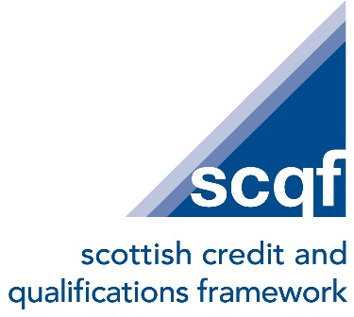

Job Title: Quality Officer

Contract: Permanent, 35 hours per week

Location: SCQF Partnership Offices, Glasgow city centre and hybrid based on business need.

Salary Band: SCQF Band 2 (£28,500 - £37,000)
Reporting to: Head of Assurance

Job purpose

Working as a member of the Assurance team, you will assist and support our work in maintaining the quality processes that underpin Scotland’s National Qualifications Framework. You will help keep the National Register of Qualifications accurate and up to date by receiving data from external sources, tidying and checking that data, uploading it to the Register and carrying out regular, iterative Register updates. As part of the role, you will look for better and more innovative ways to support credit rating bodies and other stakeholders across Scotland.

Responsibilities:
- Commit and contribute to the delivery and reporting of SCQFP’s strategic priorities.
- Support the delivery and compliance of quality assurance processes related to Scotland’s National Qualifications Framework (NQF)
- Be the main point of contact for Tertiary Quality Enhancement Review (TQER) related activity and help support quality assurance work with colleges and universities, including credit rating activity.
- Contribute to the ongoing maintenance, accuracy and development of the National Register of Qualifications, including receiving, cleansing and uploading data, making regular updates, checks and improvements.
- Assist with Quality Committee secretariat responsibilities and other operational groups, including preparation of papers, minute taking, meeting organisation and follow-up actions where required.
- Collaborate effectively with Assurance team members and wider organisational colleagues to ensure consistent implementation of policies and best practice.
- Engage confidently with internal and external stakeholders including credit rating bodies, colleges, universities, UCAS, Insights and others.
- Support the collection, analysis and reporting of data, intelligence and feedback, including survey results analysis and external reporting to partners.
- Contribute to internal, cross-functional and international projects that aim to enhance the integrity and relevance of Scotland’s qualifications landscape.
- Support team collaboration, document management, knowledge and data sharing, through the effective use of MS Teams channels and SharePoint.
- Schedule, co-ordinate, deliver and monitor the impact of relevant workshops and webinars with SCQFP colleagues.
- Contribute to the development of e-learning resources for credit rating bodies, including post-workshop administration duties.
- Contribute to the objectives within the SCQFP digital strategy.
- Undertake other duties appropriate to the scope and grading of the post.

Person specification

This role would suit a person with SCQF Level 7 equivalent skills or experience

Essential criteria

The post holder will:

- Demonstrate a commitment to the organisation’s values of integrity, respect, collaboration and enabling.
- Possess excellent written and verbal communication skills
- Be confident in carrying out data analysis, survey results analysis and project report writing for internal and external audiences.
- Be very well organised, able to manage competing priorities and work effectively in a fast-paced environment.
- Be adaptable to change, quick to learn and able to respond positively to changing priorities and new ways of working.
- Experience of carrying out administrative tasks accurately and working confidently with external organisations and contributing positively as part of a wider team.
- Demonstrate an understanding of quality assurance principles and willingness to engage positively with quality assurance and enhancement work.
- Understand the aims of the SCQF and the role of the SCQF Partnership.
- Be GDPR aware and conscious of the importance of handling personal, organisational and partner data responsibly.
- Demonstrate a commitment to continuous professional development, particularly an interest in keeping up to date with AI and digital developments in business and compliance assessment processes.
- Have experience of delivering shared goals through partnership working.
- Be highly competent in the use of MS Office packages and cloud-based storage solutions, including Word, Mail Merge, Excel, Excel pivot tables, data analysis, Power BI, SharePoint and MS Teams (or similar video conferencing platforms).

Desirable competencies / experience

- Experience of supporting events or coordinating study visits.
- Familiarity with at least one aspect of Scotland’s Lifelong Learning sector
- Have an interest and commitment to harnessing AI in an ethical and responsible way for organisational benefit.

