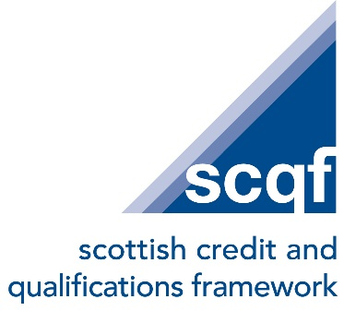

Job Title: Lead: Quality Assurance

Contract: Permanent, 35 hours per week

Location: SCQF Partnership Offices, Glasgow city centre and hybrid based on business need.

Salary Band: SCQF Band 3 (£39,000 - £48,750)
Reporting to: Head of Assurance

Job purpose

Working as one of a team of Lead Officers across the organisation, the postholder will help assure the quality and integrity of Scotland’s National Qualifications Framework, its National Register of Qualifications and its reputation transnationally, whilst enhancing our organisation’s support for credit rating activity across Scotland in new and innovative ways.

Responsibilities

The post holder will:
- Work alongside the Head of Assurance to support the delivery and reporting of SCQFP’s strategic priorities.
- Lead and manage the ongoing monitoring, accuracy and development of the National Register of Qualifications, working collaboratively with internal and external stakeholders to implement improvements.
- Manage, review and develop SCQFP’s policies, procedures and guidance relating to SCQF Principles and Quality Assurance model for approved CRBs and credit rating processes.
- Work closely with the Quality Assurance Agency (QAA) in delivering relevant aspects of Scotland’s Tertiary Quality Enhancement Framework (TQEF), providing expert opinion on the tertiary sector’s credit rating activity.
- Lead and develop new and efficient methods of engaging more effectively with credit rating bodies, partners and colleagues in using digital approaches to support quality improvement.
- Develop and deliver training and capacity building for partners, Credit Rating Bodies and other related organisations.
- Lead on the development and delivery of new e-learning resources, as part of the organisation’s Digitalisation Strategy, to enhance efficiency and engagement with external stakeholders.
- Manage, develop and implement programme(s) and projects to enable and strengthen credit rating capacity building in particular sectors, including the increase in engagement with third parties,
- Coordinate, produce and contribute to papers for, and report, to the SCQFP Board’s Quality Committee and other related groups and committees.
- Carry out and disseminate relevant research on emerging practice and policy impacting on the work of SCQF and its partner organisations.
- Lead and manage the collection, analysis, and reporting of data, intelligence and feedback to inform strategic decisions and continuous improvement efforts.
- Work alongside and support all the SCQF teams responding flexibly to emerging priorities.
- Represent and advocate for the SCQF on national groups and at external forum, promoting the Framework’s key themes of equity, mobility and access.

Person specification

This role would suit a person with SCQF Level 9 equivalent skills or experience

Essential criteria

The post holder will:

- Possess in-depth experience of developing and implementing quality processes and procedures, with a commitment to continuous improvement.
- Demonstrate an understanding of the credit rating and quality assurance requirements for qualifications in Scotland.
- Demonstrate a commitment to the organisation’s values of integrity, respect, collaboration and enabling.
- Be familiar with at least one aspect of the lifelong learning sector.
- Possess excellent written communication skills, together with the ability to write reports and scoping papers in new fields of work.
- Display strong analytical skills and the ability to assess evidence to provide conclusions for internal and external audiences.
- Have strong project management skills, including planning, prioritisation and delivering to deadlines in a dynamic environment
- Enjoy being part of a wider team taking a collaborative approach to problem solving.
- Have good presentation skills.
- Demonstrate a commitment to continuous professional development, particularly in keeping up to date with AI and digital developments in quality assurance.
- Have experience of delivering shared goals through partnership working.
- Be very competent in the use of MS Office packages and cloud- based storage solutions, including Word, Mail merge, Excel, SharePoint and MS Teams (or similar VC platform).

Desirable competencies / experience

- Awareness of Lean or Agile thinking for delivering process improvements.
- Experience of developing or delivering training programmes.
- Have an interest and commitment to ethical and responsible use of AI for organisational benefit.

