

INVITATION TO TENDER FOR PROVISION OF PROJECT MANAGEMENT SERVICES
DELIVERY OF A NATIONAL SYSTEM FOR RPL IN SCOTLAND: PHASE 1

- Introduction

This tender specification invites interested parties to submit the proposal for delivering project management services on behalf of SCQF Partnership in relation to a significant Recognition of Prior Learning initiative. The consultant/s will devise and deliver a Development Plan, with demanding deadlines for the first phase delivery of a national system for RPL in Scotland.

- Background to the SCQF Partnership

The Scottish Credit and Qualifications Framework Partnership (SCQFP) is an independent not-for-profit company with charitable status, responsible for upholding the quality and integrity of Scotland’s National Qualifications Framework, the SCQF. The Partnership works to secure the Framework’s relevance in the current and evolving learning and skills landscape in Scotland, seeking to raise awareness and understanding among learners and employers and those who advise them, focusing its efforts on increasing:

- access to lifelong learning for those who face most barriers to education and training
- mobility for Scotland’s learners and workforce to transition to further learning and training and the new industry the economy requires
- equity in how comparable learning and skills are recognised by learning providers and employers.

The Company objectives are:
- to maintain the quality of the Framework.
- to further promote and develop its use.
- to maintain and develop relationships with other frameworks in the UK and Europe.

The Partnership Board comprises 9 Trustees, 4 of whom are Appointed Members of
the company being the Chief Officers of:

- College Development Network.
- Quality Assurance Agency for Higher Education.
- Scottish Qualifications Authority (or its successor body)
- Universities Scotland.
The Partnership is largely funded through annual grants from Scottish Government and the Scottish Funding Council. The CEO and leadership team liaise closely on delivering national priorities with both bodies.

The Partnership’s Board recently approved a new set of Strategic priorities (3 pillars) for 2025-30, following an extensive consultation, evaluation and organisational development review process. A re-structure of the team of 13 is currently underway to underpin the new priorities and a revised operating model, with Heads of Assurance, Operations, and Pathways Policy reporting to the CEO.

- Current position

The Framework (SCQF) provides the mechanism for RPL in Scotland, providing a set of Principles (Principles 20-25) to which all Credit Rating bodies must adhere. These are used to develop policies and processes by institutions and other organisations in Scotland including SCQF Credit Rating Bodies (CRBs). QAA has also produced guidance for universities on RPL policies and the SCQF Partnership continues to support education providers and employers with tools and resources to enhance their delivery of RPL, from informal, non-formal to formal.

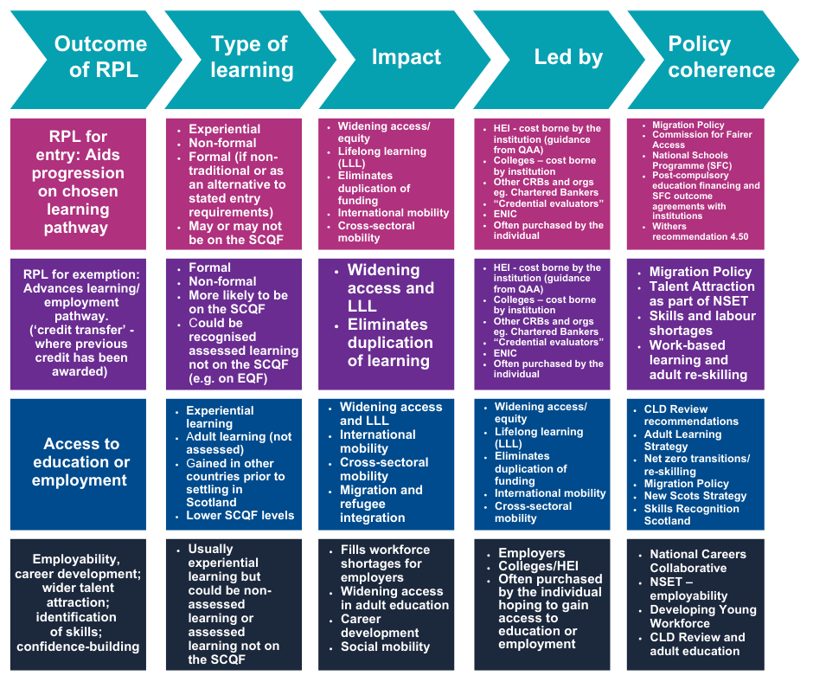

The SCQF Partnership has been calling for a national policy and strategy for RPL to be adopted by the Scottish Government for many years and in Autumn 2024 was invited to submit a proposal and business case for a national approach.

3.1 SCQF Partnership proposal to Scottish Government

Our proposal (contained in Annex 1) to Scottish Government stated that:

“A coherent national system and overarching vision of learner entitlement to RPL will help ensure that all actors in education and skills are adopting and implementing RPL practices. The objective will be to embed the recognition of prior learning and skills of school leavers, adult learners, and those settling in Scotland within our education and skills system. This approach aims to value diverse learning pathways, enable shorter and more efficient progression routes, and align with labour market demands.”

As a result, SCQFP recently secured Scottish Government commitment to developing a National System, through its stated Programme for Government published in May 2026.

“To capitalise on economic opportunities, we need people with the skills to grasp them.”
(Actions to enable this include):

“Establishing a national Recognition of Prior Learning system - formally acknowledging an individual’s skills and knowledge gained through work experience, training, or other learning outside of formal education.”

Ministers have supported the development of a system that properly values and acknowledges prior learning, skills and experience, enabling learners to gain credit/recognitions for existing skills, reducing the need to repeat learning and enabling quicker progression through education and training. Prior to the Scottish Parliamentary elections in May 2026, there is an expectation that a number of actions will be completed by Spring 2026:

3.2 Key actions required

- Assemble a steering group of employers, education providers (universities, colleges, training), and agencies, with international best practice input and focusing on leveraging existing resources and partnerships to agree a coherent, cost-effective approach to delivering a national approach.

- Develop a plan to streamline formal RPL for college and vocational students entering universities, using the Joint Articulation Group as the key vehicle for consultation and delivery (existing priority for the Scottish Funding Council).

- Focus on existing RPL and micro credentials pathways and processes and create a pilot programme for employers to utilise existing micro-credentials and benchmarking of skills using the SCQF through efficient informal RPL processes. Focus on priority industries with identified skills shortages.

- Invitation to tender

Interested parties are invited to tender to deliver project management services to the SCQF Partnership with the primary objective of delivering the actions set out in the Scottish Government’s funding objectives for the SCQFP for fiscal year 2025-26 (as above).

The successful tenderer will report directly to the CEO and be provided with necessary secretariat, communications and project development support by the Head of Pathways Policy and the wider SCQFP team.

4.1 Specification for services

In the period from end June 2025-March 2026 the contractor will manage the delivery, with the support of the SCQFP team and its existing networks with employers and education providers, the following outputs:

- The creation and management of a National Steering Group for Scotland’s RPL System, which is inclusive in its approach and secures buy-in and ownership for a diverse range of interests, including Scottish Government officials, learners themselves, industry representation and tertiary institutions.

- A development plan for formal RPL for articulating students into HEI from college and vocational based learning pathways, embedding approaches developed by the Joint Articulation Group convened by universities and colleges, consulting with the Scottish Funding Council and the Commissioner for Widening Access.

- A road map, demonstrated through an action research pilot, for the use of informal RPL and micro-credentials by employers working in partnership with education and training providers and proposing cost-effective funding model for credit rating of micro-credentials in one priority industry. SCQFP will provide guidance on existing networks and relationships on which this will be built. Additional funding will be available for this activity.

- An evidence-based reporting framework for assessing the effectiveness of actions for regular, transparent reporting to the SCQFP Board of Directors, Scottish Government and the education and skills community

- Regular progress reports to the CEO and be prepared to discuss the project with the SCQFP Board and Scottish Government Ministers as/if required

- Identify additional early research and data analysis activity necessary to direct the focus of the development plan, for which additional funding will be made available.

4.2 Your approach

Interested parties are invited to review SCQFP’s original Proposal in Annex 1 and outline your approach to project management for this complex brief, involving a diverse range of actors in the Scottish education, skills, and economy landscape. Additional funding will be available to support the delivery of specific project deliverables, following agreement of a project development plan.

Your approach should consider:
- how you would approach defining clear roles, responsibilities, and performance reporting
- how you will approach the opportunities and risks for this project
- the membership of the Steering Group and its governance
- The inter-relationships within existing widening access, RPL and skills recognition initiatives and reporting structures in Scotland’s tertiary sector and how you would intend to avoid duplication of effort and competing agenda
- The need for ‘quick wins’ as well as longer term planning for delivery and future impact.
- Your resourcing of the project management, as a consultant or consultancy business sharing the delivery work across a number of consultants/ associates.

- Budget

A budget of up to £30,000 (including VAT) is available for this work over an 8-month period. Contractors are invited to provide a breakdown of fees, including day rates and inclusive of all expenses.

- Tender instructions

Tenders should include the following information:
- Your understanding of the brief and your proposed methodology
- Brief example/s demonstrating your record in delivering national level complex projects.
- Your project management approach, including a brief overview of roles, responsibilities and reporting.
- Key milestones within the contract period that you believe will be critical to delivery over the 8-month period.
- A high level, brief, risk assessment of the project and how you would intend to mitigate the risks and challenges encountered.
- The total fee (inclusive of VAT) for the contract period, for each element of service provided (or example, day rates of the project team), inclusive of all expenses.
- Brief CVs of the consultant/s who would deliver the service.
- Two referees /references of those who know your work.
- Your commitment to Fair Work, if employing staff.
- A written statement assuring SCQFP that you will have business insurance and be registered with HMRC tax purposes as a small business.

Please do not hesitate to contact Pauline Radcliffe if you require further information or would like to discuss prior to submitting a quotation.
E-mail: p.radcliffe@scqf.org.uk

- Deadline for tender submission
Tenders, of no more than four pages (with CVs appended), should be submitted by Tuesday 10 June 2025 at 17.00 by email to Pauline, as CEO.
An initial inception meeting will arranged in the week beginning 23 June and thereafter contractor(s) will be required to work flexibly over the year ahead.

- Assessment of tenders

Tenders will be assessed on the following criteria:

- Demonstrable executive level experience and a compelling reputation for delivery within the tertiary education and /or skills sector and with Scottish Government officials at a senior level
- A passion for and understanding of RPL Policy and processes, and its benefits for recognising wider learning and achievement and /or practical application of credit transfer within institutions.
- Your understanding of the project’s requirements and key milestones for delivery
- History in delivering complex projects, collaborating with diverse stakeholders and within challenging deadlines
- Evidence of understanding the challenges and risks associated with delivery the brief and how you might approach these
- The quality and experience of any proposed team as well as cultural fit
- Approach to wellbeing, equality, and diversity in the workplace
- Value for money.

